SMART DOCTOR APPOINTMENT SCHEDULER
Using Forward Chaining (Rule-Based AI)

Submitted by
Name: Kartik Mathur
Registration Number: 25BCE11381
Course: CSA2001 – Fundamentals of AI and ML
Project Type: Bring Your Own Project (BYOP)
Date: March 2026

TITLE
Smart Doctor Appointment Scheduler using Forward Chaining (Rule-Based Artificial Intelligence)

INTRODUCTION
This project develops a Command Line Interface (CLI) based intelligent system that schedules doctor appointments using the Forward Chaining technique of Artificial Intelligence.

MOTIVATION OF THE PROJECT
In college hospitals and clinics, patients often face long waiting times and difficulty in finding available doctors according to their speciality and preferred time. This project aims to solve this real-world problem using AI concepts learned in the course.

PROBLEM STATEMENT
To create an intelligent rule-based system that automatically matches patient requirements (speciality and time) with available doctors using Forward Chaining and provides instant confirmation or alternative suggestions.

OBJECTIVE OF THE PROJECT
- Implement Forward Chaining for intelligent decision making
- Provide a simple and user-friendly CLI interface
- Demonstrate practical application of AI concepts

EXISTING METHODS
Traditional appointment systems rely on manual booking or simple web forms without applying any AI-based reasoning.

PROS AND CONS OF EXISTING METHODS
Pros:
Simple to understand and use
Cons:
No intelligent rule checking
Long waiting time
Possibility of human error

HARDWARE AND SOFTWARE REQUIREMENTS
Hardware: Any computer system
Software: Python 3.x

METHODOLOGY AND GOAL
The system uses production rules and Forward Chaining to infer the best possible appointment. Patient input is taken as facts, and rules are applied sequentially to reach a decision.

FUNCTIONAL MODULES DESIGN AND ANALYSIS
- Doctor Database Module
- User Input Module
- Forward Chaining Reasoning Module
- Output and Confirmation Module

ALGORITHM DEVELOPMENT
Forward Chaining Algorithm:
Start with known facts (patient requirements)
Apply rules one by one
Derive a conclusion (appointment booked or not available)

SOFTWARE DIAGRAM 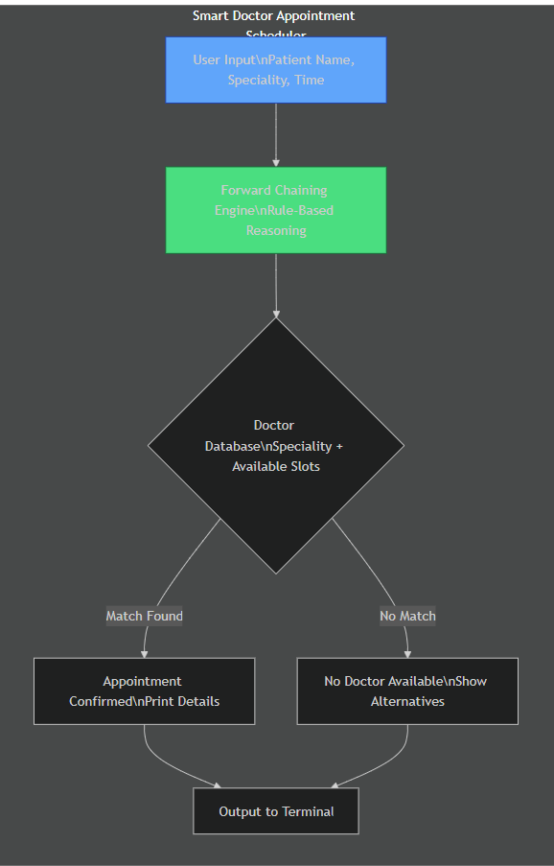

CODING
The complete implementation is written in Python and available in the file main.py.

OUTPUT
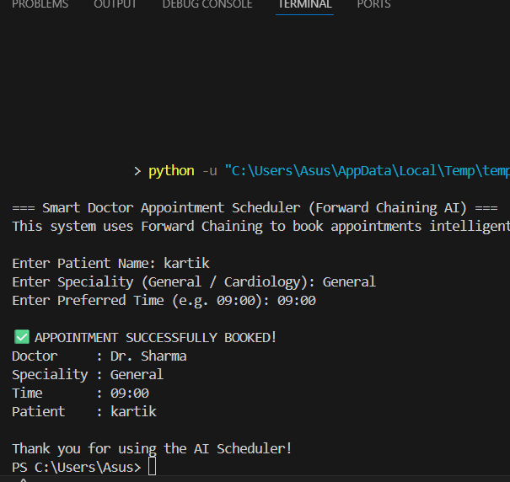

KEY IMPLEMENTATIONS
- Rule-based Forward Chaining logic
- Multiple doctor support with different specialities
- Real-time slot availability checking

SIGNIFICANT PROJECT OUTCOMES
Successfully developed a working AI-based system using Forward Chaining concepts.

TESTING AND REFINEMENT
The system was tested with multiple inputs including valid and invalid cases. Error messages were refined to improve user experience.

REAL-WORLD APPLICATIONS
This system can be extended to hospital management systems, online booking platforms, and scheduling applications.

CONTRIBUTION / FINDINGS
This project demonstrates how simple AI techniques like Forward Chaining can solve real-life problems efficiently.

LIMITATIONS
- Uses static data
- No graphical interface (CLI-based system)

CONCLUSION
This project successfully applies Artificial Intelligence concepts to solve a real-world scheduling problem.

FUTURE ENHANCEMENTS
- Add database support (SQLite)
- Implement Backward Chaining
- Develop a GUI or web-based interface
- Integrate with real hospital systems

REFERENCES
Course Material – Problem Solving Methods and Knowledge Representation
Artificial Intelligence: A Modern Approach by Stuart Russell and Peter Norvi

